Create a Private DNS Zone in azure
Search DNS Zone in portal.
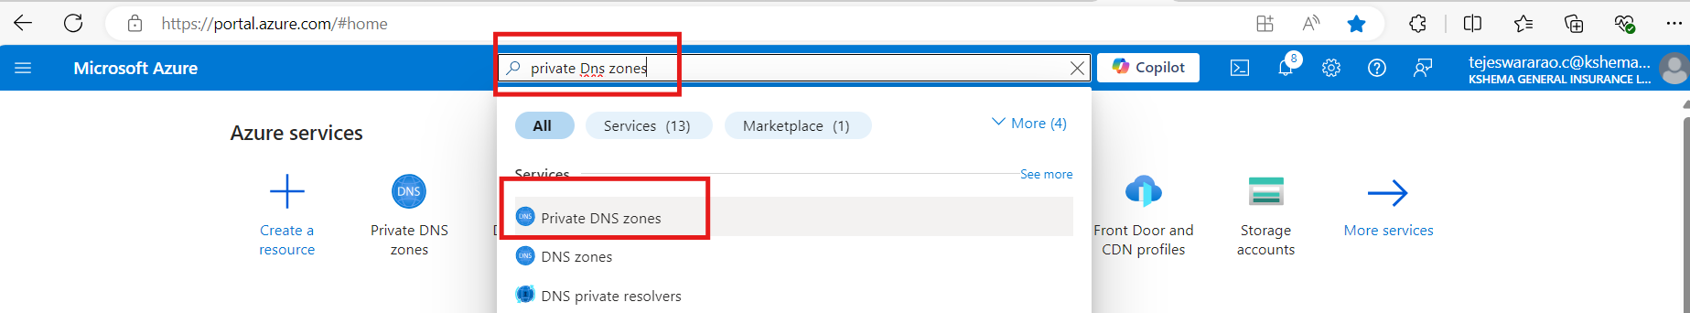
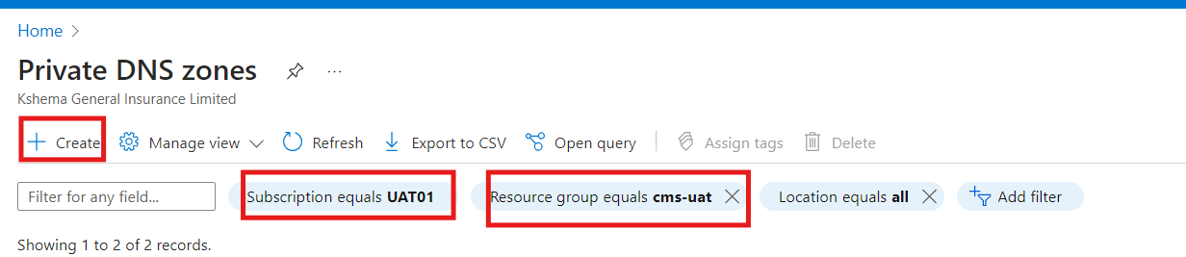
Fill the below details and create.
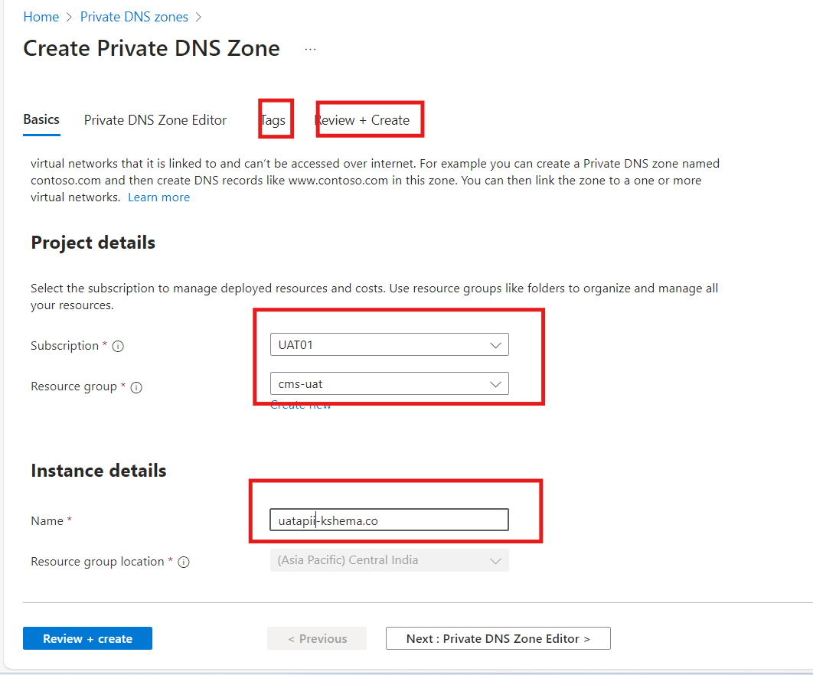
After creation private DNS Account, below window open, then select virtual netework as shown in box.
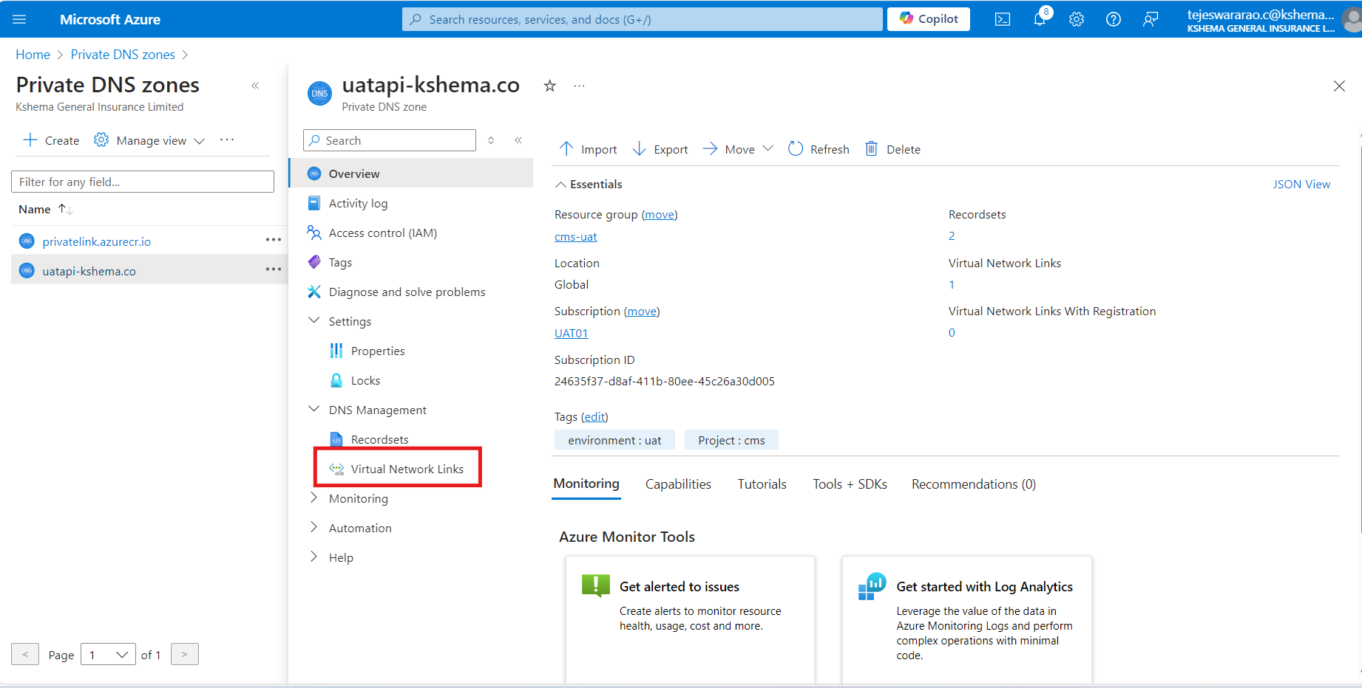
Fill the details and click on Create.
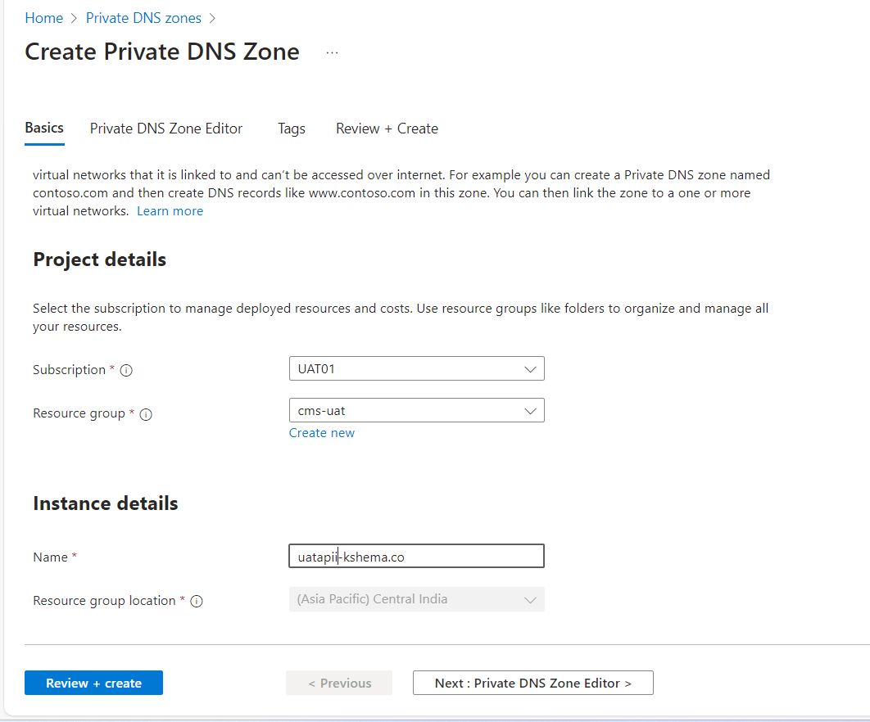
Then showing as below
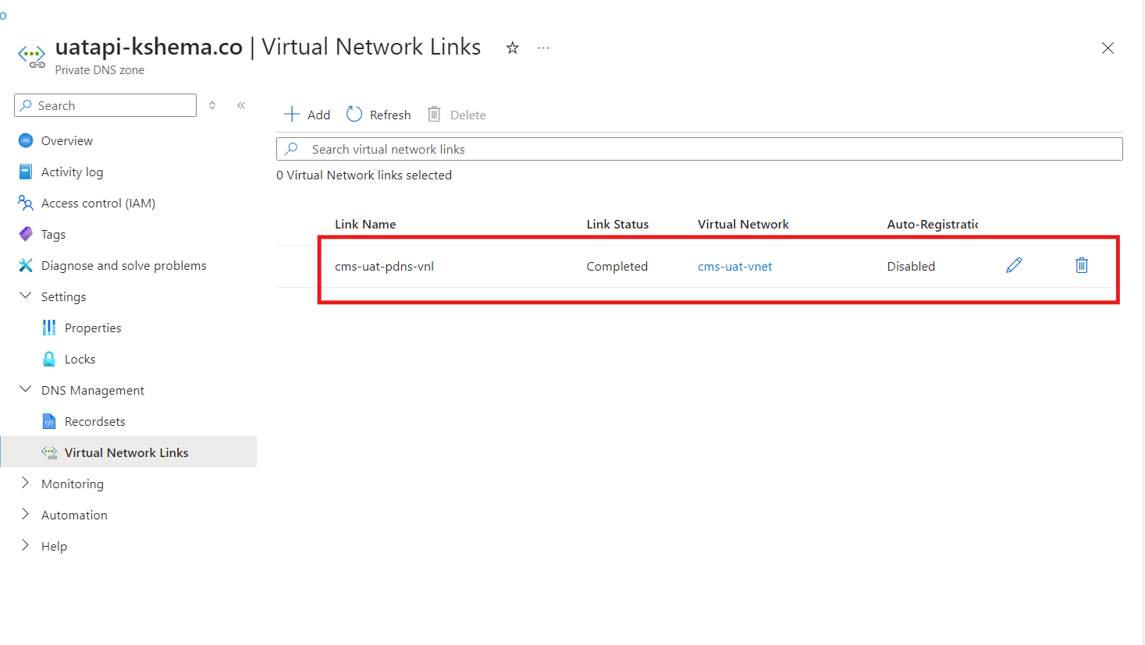
Now select Records and click on Add
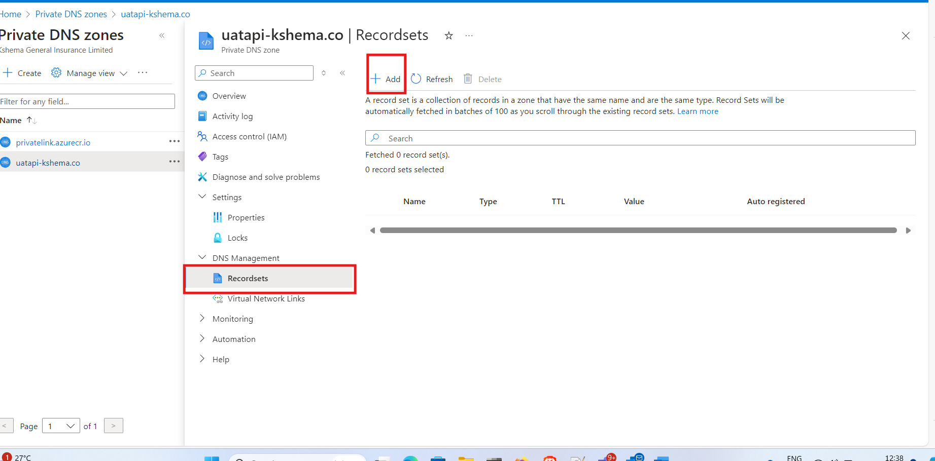

Fill the necessary details as shown in below image then add.
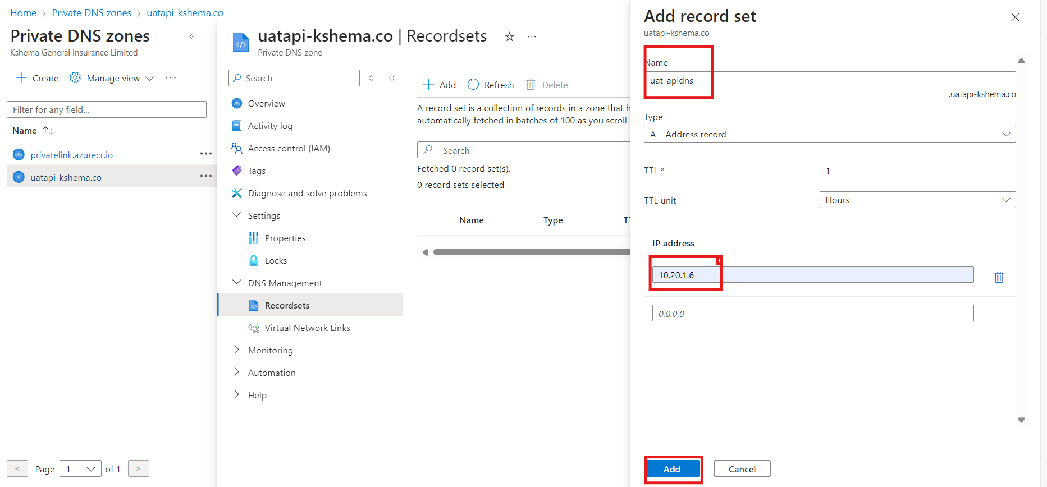
Once Recordsets add , then created CNAME record it will create as shown in below image.
